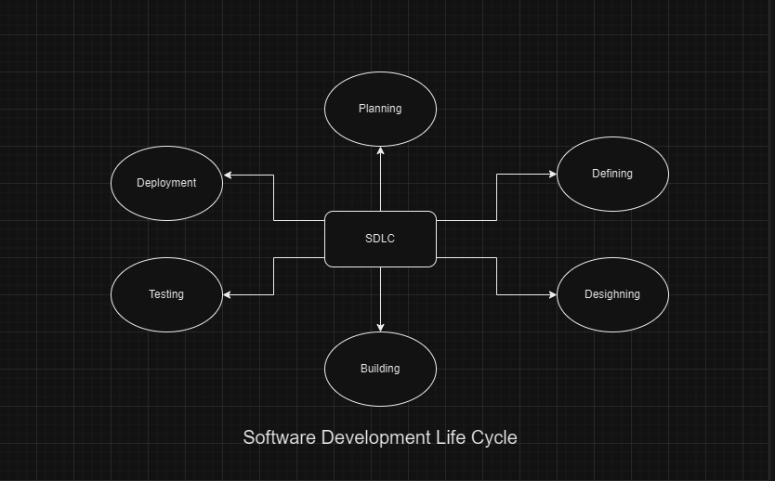

**1.Requirements Phase**

Identify and document project requirements.

Gather input from stakeholders.

Establish project scope and objectives.

**Importance:** Sets the foundation for the entire project by defining what needs to be built and why.

**2.Design Phase**

Create system architecture and design.

Develop detailed specifications.

Plan user interface and user experience.

**Importance:** Translates requirements into a blueprint for development, ensuring that the system will meet functional and non-functional requirements.

**3.Implementation Phase**

Write code according to design specifications.

Develop databases, APIs, and other components.

Conduct code reviews for quality assurance.

**Importance:** Involves the actual coding and development of the software based on the design specifications.

**4.Testing Phase**

Perform various tests (unit, integration, system, etc.).

Identify and fix defects and bugs.

Ensure software meets quality standards.

**Importance:** Ensures that the software functions correctly and meets quality standards before deployment.

**5.Deployment Phase**

Deploy software to production environment.

Monitor performance and gather user feedback.

Provide user training and support.

**Importance:** Involves releasing the software into the production environment and making it available to users.

